NSAA/ENOA BASKETBALL
OFFICIALS’ CLINIC

The NSAA/ENOA will be conducting a 3-Person Basketball Officials’ Clinic on Saturday November 29, 2008. The purpose of the camps is to train officials in 3-person mechanics. . The clinic will consist of classroom instruction followed by court time observation and evaluation.

3-Person Mechanics Clinic Lincoln North Star High School November 29, 2008

Classroom: 8:00 aM – 9:00 AM

Court Time: 9:00 AM -- 12 Noon

Registration Fee; $ 35.00 Non-Refundable

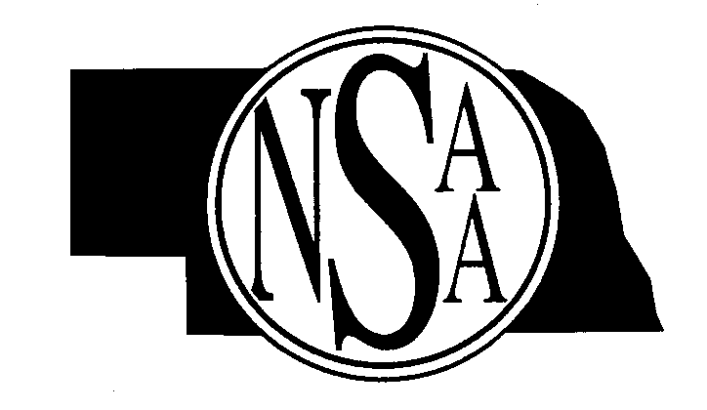
Evaluators and Clinicians: ENOA
Dick Zierke rzierke@neb.rr.com
Shane Smith ssmith6@neb.rr.com
Willie Beamon nyg21db@gmail.com

Clinic will be limited to first 24 applicants.
_______________________________________________________________________________________________________
North Star Clinic Saturday November 29, 2008
Complete the registration forms with all the necessary information and enclose payment of $35.00.

Return by Tuesday November 25, 2008

Name____________________________________Address___________________________________________________

City____________________________State______Zip_____________________Telephone # ________________________

E-mail _____________________________

MAIL TO: NSAA
P.O. Box 5447
Lincoln, NE 68505-0447

